Ashanti Region Tops Violent Incidents Chart in June-July Monitoring Exercise- FOSDA
The Ashanti Region, according to FOSDA’s monitoring of violence, recorded the highest number of violent incidences in Ghana.
Out of the total 86 cases recorded within the period of 1st June to 31st July 2022, Ashanti region topped the list with a total of 24 incidents, representing 28% of total incidents.
Next to follow keenly is the Greater Accra Region with 21 incidents, representing 24% of the total cases recorded.
However,the Bono Region was the most peaceful region in Ghana within the period under review with no violent case recorded.
The 86 recorded cases within the two month period of monitoring revealed that, a total of 167 injuries and 41 deaths occurred in the regions under monitoring where 10% of the dead were women.
Physical violence, including assault also topped the list of violent incidents with 49 reported cases representing 57% of the total cases recorded whiles Gun related violence followed closely with 15 case which accounted for 17% of the total cases recorded.
The above data in this report emanates from FOSDA’s monitoring exercise of 10 major media outlets in Ghana, covering both online and newspaper sources.

Please find below full report.

VIOLENT INCIDENTS IN GHANA
A MEDIA MONITORING REPORT
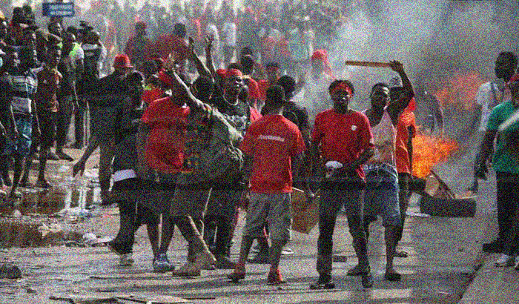

June-July 2022
By: Foundation for Security and Development in Africa (FOSDA)

Executive Summary
From FOSDA’s June-July 2022 monitoring of violent incidents in Ghana, the number of violent incidents tracked amounted to eighty-six (86). The overall breakdown includes;
- Physical Violence - 49 cases, representing 57%
- Gun Violence - 15 cases, representing 17%,
- Sexual Violence - 12 cases, representing 14%,
- Psychological Violence – 4 cases representing 5%,
- Social Violence – 3 cases representing 4%,
- Economic Violence – 2 cases representing 2% and
- Political Violence – 1 incident representing 1%.

At the regional level, Ashanti region recorded 24 incidents which contributed 28% of total incidents whiles Greater Accra (21) contributed 24%. Western North and Eastern regions recorded 8 incidents each representing 8% and Central region recorded 7 incidents representing 8%. Ten (10) regions that is Bono East, Upper East, Upper West, Western, North East, Volta, Oti, Northern, Savannah and Bono recorded a cumulative incident of 18 representing 21%. There was no violent incident recorded in the Ahafo region.
A total of 167 injuries and 41 deaths occurred. Of the 41 deaths, 63% were men and 10% were women. 10% of the injured were children. The media reportage also failed to provide details on 65% of injuries and 22% of deaths.

Physical violence was the most occurring violent incident. It occurred in 12 out of the 16 regions and contributed to 120 injuries (72%) and 26 representing 63% of deaths. On the other hand, Gun violence occurred in 5 regions i.e Greater Accra (5), Ashanti (3), Eastern (4), Western North (2) and Bono East (1). It contributed to 22% of injuries and 32% of deaths.

- Discussions on Monitoring Outcome
1.1 General Overview
In the months of June-July 2022, a total of eighty-six (86) violent incidents were reported by twelve (12) media houses including online and print media sources. The 3 major highlights are Physical Violence with 49 cases, representing 57%. Fifteen (15) of the incidents representing 17% of the total incidents were gun related. Sexual violence (12) recorded 14%. These 3 contributed (76 cases) representing 88% of the total incidents recorded.
Fig 1: Monthly comparison June & July 2022
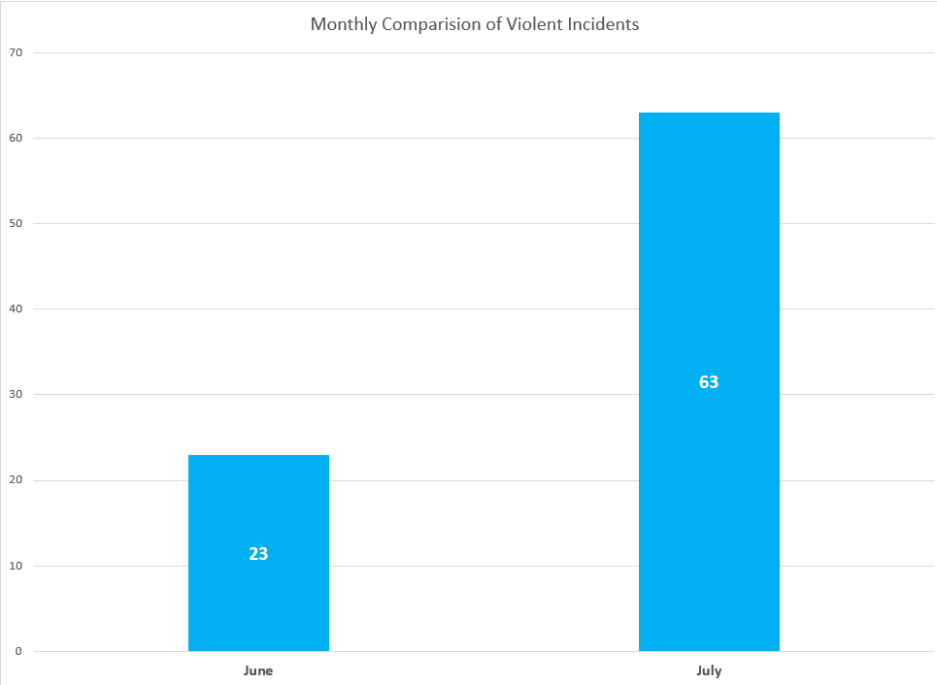
The violent incidents recorded by the selected media houses in June was a total of 23. This increased to 63 incidents nearly 200% in July.
In the current monitoring period, the breakdown of the 86 incidents includes; Physical Violence 49 cases, representing 57%, Gun Violence 15 cases, representing 17%, Sexual Violence 12 cases, representing 14%, Psychological Violence 4 cases representing 5%, Social Violence 3 cases representing 4%, Economic Violence 2 cases representing 2% and Political Violence 1 incident representing 1%.
Fig 2: Share of Violent Incidents recorded
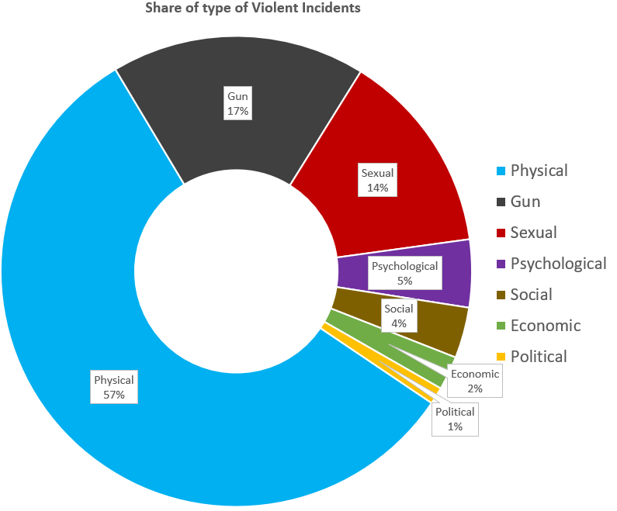
Source: Data from Monitoring

1.2 Regional Distribution of Violent Incidents Monitored
At the regional level, Ashanti region recorded 24 violent incidents representing 28% whiles Greater Accra recorded 21 representing 24%. Western North and Eastern regions recorded 8 incidents each representing 8% and Central region recorded 7 incidents representing 8%. Ten (10) regions that is Bono East, Upper East, Upper West, Western, North East, Volta, Oti, Northern, Savannah and Bono recorded a cumulative incident of 18 representing 21%. There was no violent incident recorded in the Ahafo region.
The zonal breakdown also shows that the Coastal regions (Greater Accra, Central, Western and Volta) recorded 32 incidents representing 37%. The middle zone (Ashanti, Eastern, Oti, Western North, Bono and Bono East) recorded the highest 46 incidents representing 53%. The Northern regions (Upper East, Upper West, North East, Savannah and Northern) contributed 8 incidents representing 9%. Even when the coastal and northern zone incidents are added together (40) it did not exceed the number of incidents recorded in the middle zone i.e 46.

Fig 3: Shows violent incidents recorded in 15 out of 16 regions
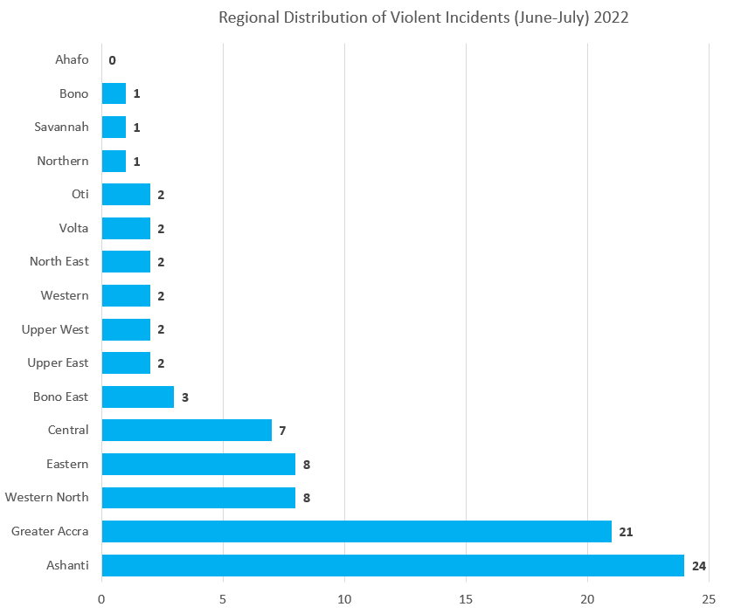

Only the Ahafo region did not record any violent incident within the reporting period as show in the figure above.
1.3 Casualties
Casualties were also recorded throughout the monitoring period. A total of 167 injuries and 41 deaths occurred. Sixty-three (63%) of deaths were men as well as 10% for women. 10% of the injured were children.

The monitoring shows that, the direct impact of violent incidents on men is higher compared to women and children. This also has consequences on the affected families. It can be seen that men (63%) died as a result of the violent incidents for the reporting period. This was followed by women (10%) and children (5%). Men also recorded 20% injuries followed by 10% injury for children.
It is important to add that the media did not specify in most case the breakdown of the injured. This could have given a much clearer picture on injuries and deaths for the reporting period.

Fig 4: Share of casualties among men, women and children from June-July 2022
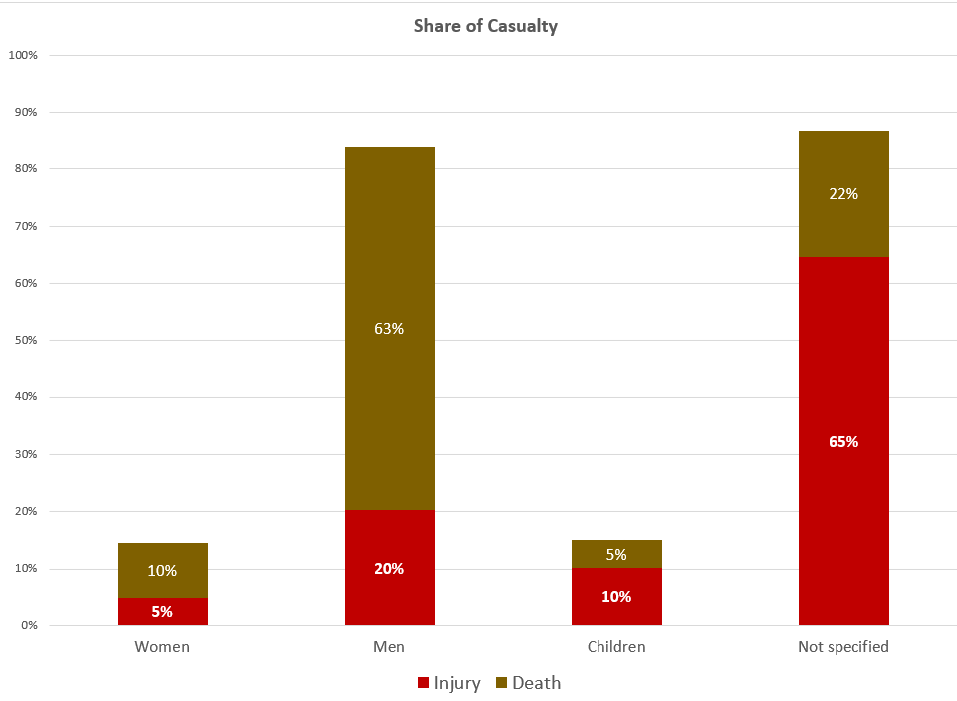

- Gun Violence
Gun violence occurred in 5 regions including Greater Accra (5), Ashanti (3), Eastern (4), Western North (2) and Bono East (1). Importantly, gun violence contributed to 22% of injuries and 32% of deaths. Table:1 gives a breakdown on the gun related incidents.
Table 1: Gun related violence tracked during monitoring period
# | Month | Region | Incident
1 | June | Greater Accra | 4 persons recorded gunshot wounds following clash between the youth of Zamrama line and some supposed military men.
2 | June | Greater Accra | Woman threatened with death by gun in Accra
3 | June | Greater Accra | One person shot and killed while two others sustained injuries during an event to lift a ban on drumming and noise making at Kokrobite.
4 | July | Greater Accra | One person shot dead and two injured following Gunshot exchanges between police and robbers in Achiaman, Amasaman.
5 | July | Greater Accra | Armed men with an AK-47 rifle, pistol and other offensive weapons were accosted on Monday morning after they allegedly attacked developers on a site. During a meeting at the Ashifla Palace, gunshots were heard.
6 | July | Eastern | Landguards, one shot in leg and other shot dead by land owner during a confrontation of the owner's land Kyekyewere in Ayensuano District
7 | July | Eastern | 35-year-old man shot dead at Kyekyewere near Teacher Mante in the Ayensoano District
8 | July | Eastern | One person shot dead and four others sustained gunshot wounds in a clash between youths of Ofoase Zongo and Brenase
9 | July | Eastern | Woman shot dead over burial rituals
10 | June | Ashanti | 4 robbers shoot at the police at Asumegya in Asante Bewkwai District
11 | June | Ashanti | Police shoot to disperse protesting students of Islamic High School in Kumasi.
12 | July | Ashanti | 23-year-old, shot by some unknown gunmen after he dropped off a friend at Sofoline.
13 | July | Western North | Three persons sustained gunshot wounds from stray bullets at Bibiani during a demonstration at the Mensin Mines.
14 | July | Western North | Chief Linguist of Sehwi Proso traditional area in the Juaboso District shot dead in a forest by unidentified persons.
15 | June | Bono East | Man shot and killed by police during a protest in Nkoranza.
Note: AK-47 is a popular type of machine gun or gas-operated assault rifle.
The outcome of the monitoring shows that gun violence has increase by 3 more incidents when the two months are compared. In the month of June, a total of 6-gun related events were reported in the media. This, increased to 9 in the month of July.

- Physical Violence
Physical violence was the most occurring incident with 49 cases (representing 57%). Ashanti region recorded 16 incidents (33%), followed by Greater Accra 10 (20%). Western North and Central recorded 6 and 5 incidents representing 12% and 10% respectively. Physical violence contributed 120 (72%) of injuries and 26 deaths representing 63%.
There were no physical violence incidents in 4 regions i.e Upper West, Upper East, Bono and Ahafo regions. Fig:5 shows the count and share of physical violence from a regional point of view.

Fig:5 Count and share of physical violence at regional level
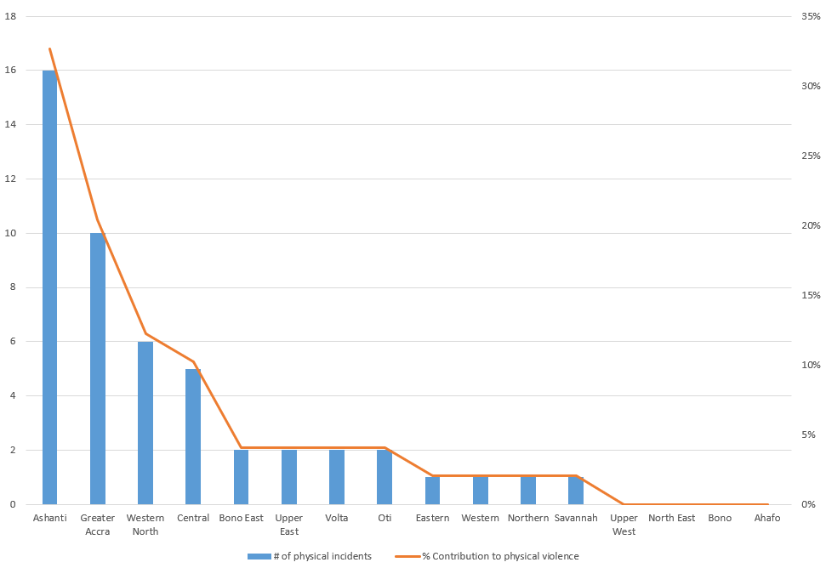

- Conclusions
As violent incident increase from June to July, physical violence remains the dominant type of violence recorded within the monitoring period. Out of the 16 regions, only Ahafo region did not record an incident. The violent incidents showed a high record (46) in middle zone.

APPENDIX 1: Media Portals where Monitoring was Conducted
# | Nature | Source
1 | Online | www.adomonline.com
2 | Online | www.citinewsroom.com
3 | Online | www.peacefmonline
4 | Online | www.myjoyonline.com
5 | Online | www.3news.com
6 | Print | www.graphic.com.gh | Daily Graphic
7 | Online | www.starrfm.com
8 | Online | www.dailyguidenetwork.com
9 | Online | www.ghanamma.com
10 | Online | www.gbcghanaonline.com
11 | Online | www.kessbenonline.com/
12 | Online | www.ghanaweb.com

About the FOSDA Violent Incidents Monitoring
The FOSDA Violent Incidents Monitoring is a media-based monitoring that focuses on 7 types of broad-based violence i.e Physical (including gun violence), Political Violence, Social Violence, Economic Violence, Sexual Violence and Psychological Violence and places where they occur. The target sources of monitoring are mainly the most sought-after online media news outlets. This is completed by reportage in the print media. The monitoring offers an opportunity for analysis, mapping and policy options on these incidents as they impact human security. A call on key stakeholders to act is the ultimate intent.

There were 12 main monitoring sources including 1 print media i.e Daily Graphic

